**Table of contents**

CHAPTER TITLE Pg.no

1. Abstract 05

2. Introduction 06

3. Components required 07

3.1 Arduino, LCD, I2C 08

3.2 IR sensor, gear motor, li-ion 09

3.3 Switch, conveyor, jumper 10

3.4 Buzzer, USB, Arduino IDE 11

4. Circuit diagram 12

4.1 Circuit Explanation 13

5. Working 14

5.1 Working of conveyor 15

6. Software implementation 16

7. Software explanation 17

8. Advantages 21

9. Disadvantages 22

10. Challenges 23

11. Future scope 24

12. Conclusion 25

**CHAPTER 1**

**ABSTRACT**

This project presents the development of an automated object counter system using an Arduino microcontroller and a liquid crystal display (LCD) for real-time monitoring. The system is designed to count objects moving on a conveyor belt by utilizing infrared (IR) sensors positioned along the conveyor path. When an object passes through the sensor’s detection range, the Arduino processes the input signal and increments the object count accordingly. The current count is then displayed on a 16x2 LCD screen, providing an easy-to-read interface for users.

The design is cost-effective and scalable, suitable for industrial applications such as packaging lines, inventory management, or quality control, where accurate and automatic object counting is crucial. The system is capable of handling different object sizes and types with minimal adjustments to sensor positioning, making it versatile for various environments.

The project demonstrates a simple yet effective application of embedded systems for industrial automation, highlighting the use of Arduino as a flexible platform for real-world problem-solving.

**CHAPTER 2**

**INTRODUCTION**

Object counting is a vital operation across numerous industries, including manufacturing, packaging, logistics, and distribution. In today's fast-paced industrial environments, precise and efficient counting of products or components is essential for maintaining seamless production lines, managing inventory, ensuring quality control, and optimizing overall operational efficiency. This project aims to develop an automated object counting system using an Arduino microcontroller, an infrared (IR) sensor, and a conveyor belt mechanism to simulate an industrial production environment.

The object counter system designed in this project offers a practical and scalable solution for industries where counting is an essential function. By employing a simple IR sensor placed along the conveyor belt, objects passing through are detected, and the Arduino microcontroller processes the input signals to increment the object count. This count is displayed in real-time on an output device such as an LCD or serial monitor, providing immediate feedback. This system not only simulates a real-world production line but also demonstrates how inexpensive, off-the-shelf components can be used to build efficient and reliable automation solutions.

**Automation in the Era of Industry 4.0**

As industries increasingly adopt automation and smart technologies in the context of Industry 4.0, there has been a significant shift toward integrating intelligent systems into manufacturing and production processes. Industry 4.0 refers to the current trend of automation and data exchange in manufacturing technologies, including the Internet of Things (IoT), cloud computing, and artificial intelligence (AI). In this context, automating tasks such as object counting has become more than just a matter of convenience—it is a fundamental requirement for industries looking to enhance precision, productivity, and real-time data tracking.

**Purpose and Objectives of the Project**

This system is particularly useful in environments where large volumes of items are produced or processed daily, such as manufacturing plants, packaging facilities, and logistics centers. The benefits of automating object counting are numerous: it enhances accuracy, increases speed, reduces labor costs, and provides real-time data for better decision-making and production management.

The system employs an infrared (IR) sensor to detect objects as they pass through the conveyor belt. When an object interrupts the IR beam, the sensor sends a signal to the Arduino microcontroller, which is programmed to increment the object count. This process is repeated for each object passing through the system. The real-time count is displayed on an output device, making it easy for operators or automated systems to monitor the production line.

In conclusion, this project lays the groundwork for a versatile and scalable object-counting system that can be adapted to a wide range of industrial applications. By leveraging automation, the system enhances efficiency, accuracy, and reliability, making it a valuable tool for industries looking to improve their production line management, quality control, and overall operational performance.

**CHAPTER 3**

**COMPONENTS REQUIRED**

**Hardware components:**

1. Arduino UNO

2. Liquid Crystal Display (LCD)-16X2

3. I2C TWI 1602 Serial LCD module

4. Infrared Sensor

5. Gear motor

6. Lithium-ion batteries

7. Switch

8. Conveyor

9. Jumpers

10. USB cable

**Software requirements:**

Arduino IDE – version 2.3.3

* Wire library
* I2C library
* EEPROM library

**1. Arduino UNO:**

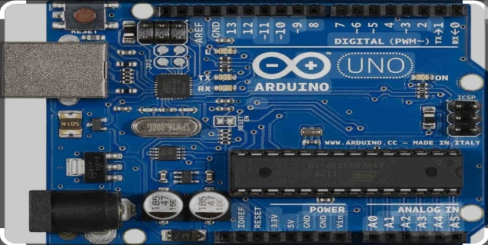

The Arduino Uno is a microcontroller board based on the ATmega328P, widely used for beginner and hobbyist electronics projects. It features 14 digital input/output pins, 6 analog inputs, a 16 MHz quartz crystal, and a USB connection for easy programming. It is known for its simplicity and compatibility with various shields and sensors.

**2. Liquid crystal display:**

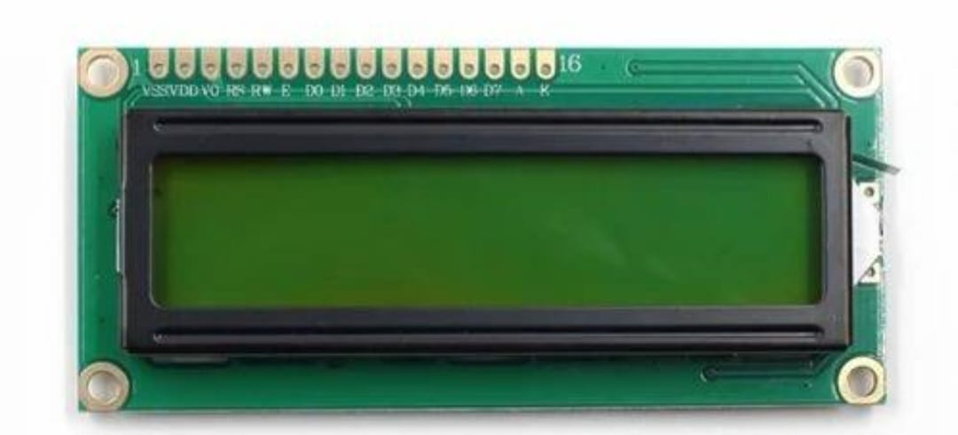

A Liquid Crystal Display (LCD) is a flat-panel display that uses liquid crystals to control light passage for displaying images. It aligns liquid crystals between polarizing filters, allowing backlight or reflected light to create visible text or images. LCDs are commonly used in devices like watches, calculators, and screens for electronic projects.

**3. I2C TWI 1602 Serial LCD module:**

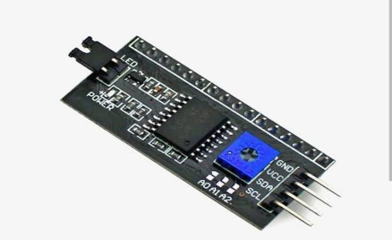

An I2C (Inter-Integrated Circuit) module is a communication protocol that allows multiple devices to connect and communicate with a microcontroller using only two wires: SDA (data line) and SCL (clock line). It simplifies connections in electronic projects by enabling multiple devices to share the same bus while maintaining unique addresses.

**4. Infrared Sensor:**

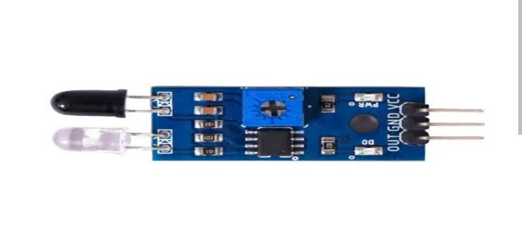

An IR (Infrared) sensor detects infrared light and is used to sense the presence or movement of objects. It consists of an infrared emitter and a photodetector, which measure infrared radiation's intensity. When an object approaches, the emitted infrared light reflects to the sensor, triggering a response. These sensors are widely used in applications such as remote controls, security systems, and obstacle detection in robotics. Their simplicity and effectiveness make them popular in various electronic projects and devices.

**5. Gear motor:**

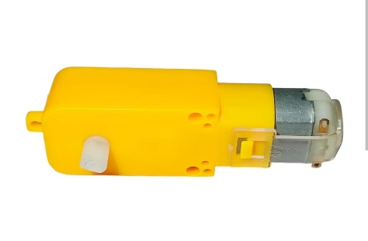

A gear motor is an electric motor paired with a gear reducer that increases torque and reduces speed for various applications. Commonly used in robotics and automation, gear motors provide precise control and higher power output.

**6. Lithium-ion batteries:**

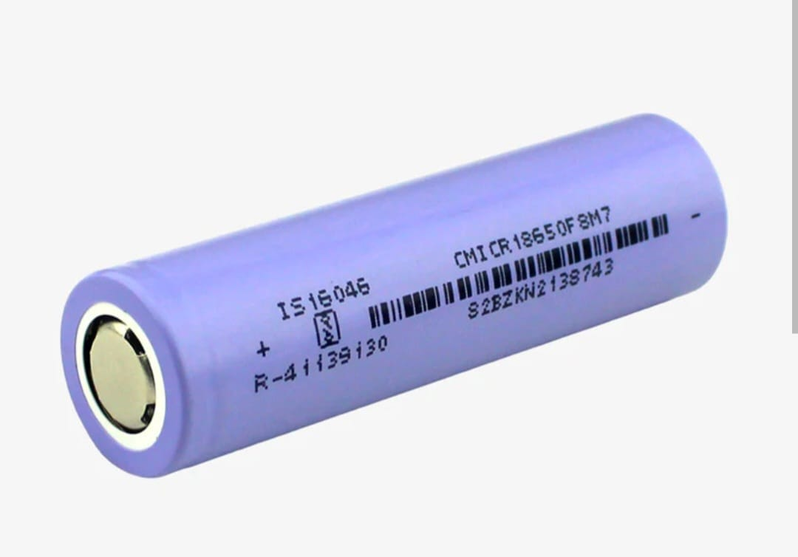

Lithium-ion batteries are rechargeable power sources that utilize lithium ions for energy transfer. They offer high energy density and a lightweight design. Due to their long lifespan and efficiency, they are widely used in portable electronics and electric vehicles.

**7. Switch:**

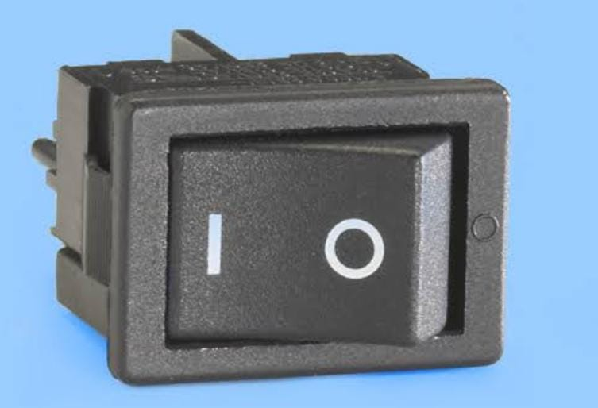

An on-and-off switch is a simple electrical device used to control the flow of current in a circuit, allowing users to turn a device or system on or off. These switches can be toggle, push-button, or rocker types, and are commonly found in household appliances and electronics.

**8. Conveyor:**

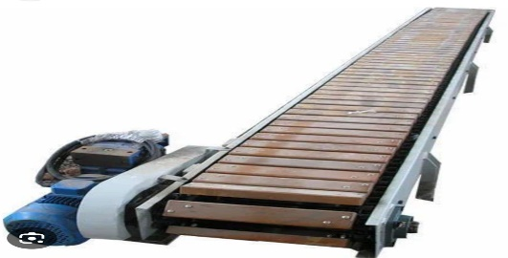

A conveyor is a mechanical system designed to transport materials or products from one location to another within a facility. Commonly used in manufacturing and logistics to send objects in a particular path.

**9. Jumpers:**

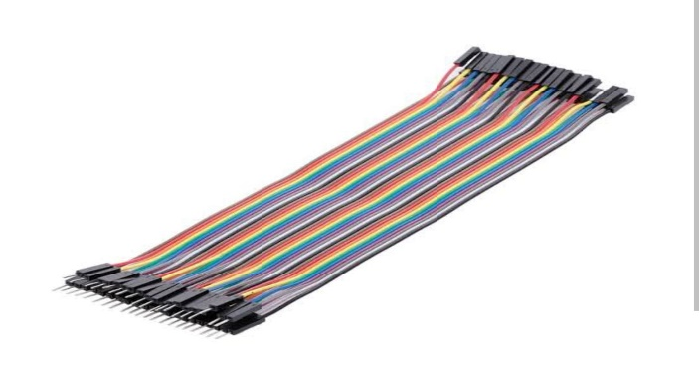

A jumper is a short length of wire or a connector used to create a temporary electrical connection between two points in a circuit. Often utilized in electronic prototyping and configurations, jumpers can enable or disable specific functions on circuit boards or devices.

**10. Buzzer:**

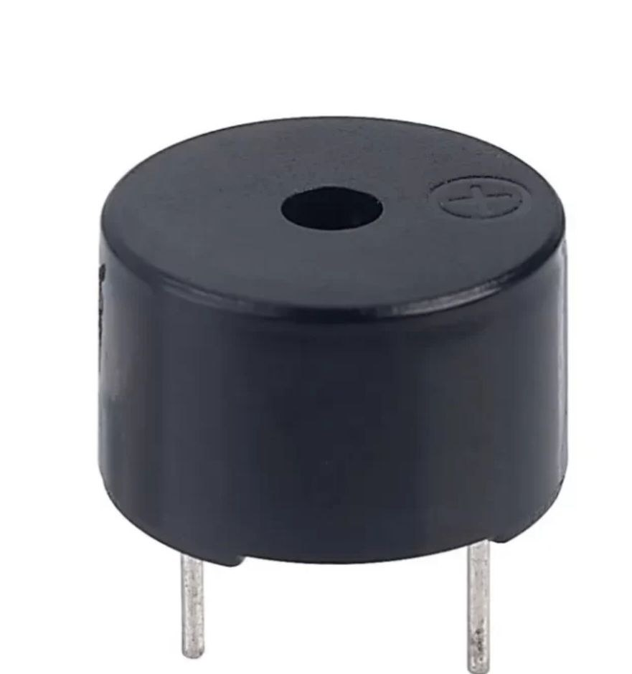

A buzzer is an electroacoustic device that generates sound in response to an electric signal. It is often used in alarms, timers, and notification systems to alert users through audible tones.

**11. USB cable:**

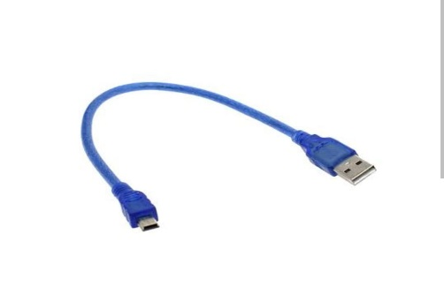

A USB cable for Arduino is used to connect the Arduino board to a computer for programming and power supply. It facilitates data transfer and communication between the board and the computer, enabling users to upload code and monitor the board's output.

**12.Arduino IDE-version 2.3.3**

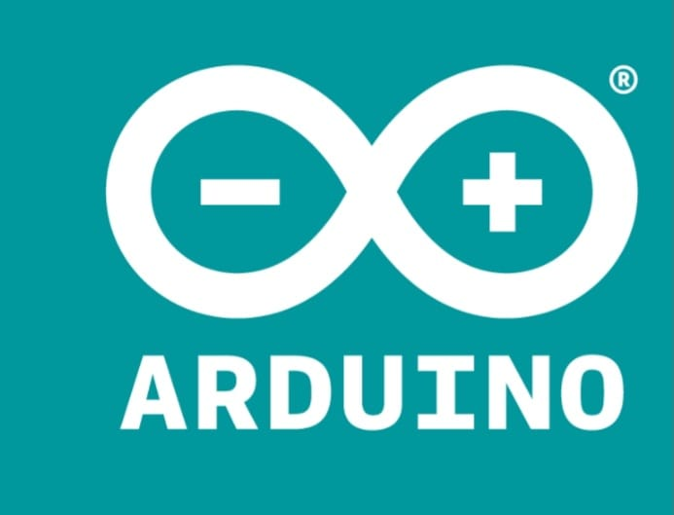

The Arduino IDE (Integrated Development Environment) is software used for writing, compiling, and uploading code to Arduino boards. It provides a user-friendly interface with features like syntax highlighting, code examples, and library management, making it accessible for beginners and experienced developers alike.

**CHAPTER 4**

**CIRCUIT DIAGRAM**

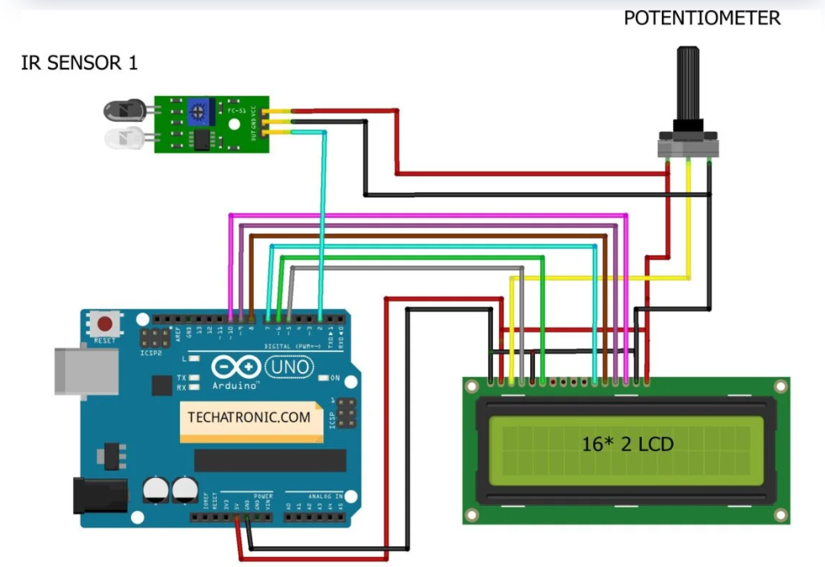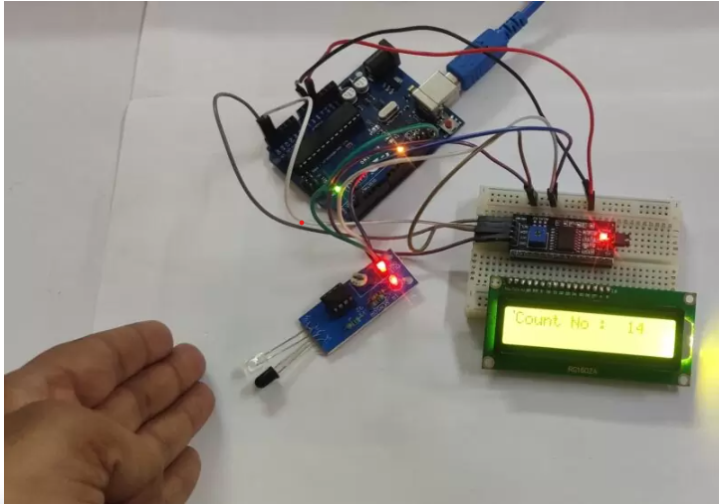

Fig1.Circuit diagram Fig.2 Implementation of the circuit

This project involves the use of an Arduino microcontroller to count objects passing on a conveyor belt using an IR sensor, and then displaying the count on a 16x2 LCD via an I2C communication module. Here's a detailed explanation of the circuit:

**Components:**

1. **Arduino (e.g., Arduino Uno)**: Acts as the central controller for the system, responsible for reading sensor data, processing it, and updating the object count on the LCD.
2. **IR Sensor**: Used to detect the presence of objects on the conveyor belt. The sensor consists of an IR emitter and receiver, and it generates a digital signal when an object interrupts the infrared beam between the emitter and receiver.
3. **16x2 LCD Display (with I2C module)**: This is a standard 16x2 character LCD, but instead of connecting directly to the Arduino’s pins, it uses an I2C module to reduce the number of connections required. The I2C protocol allows for communication using only two wires (SDA and SCL).
4. **I2C Module**: The I2C interface simplifies the connection between the Arduino and the LCD, requiring only two communication lines (SDA and SCL) along with power (VCC and GND).

**Circuit Components and Connections:**

1. **IR Sensor Connections**:
   * **VCC**: Connect to 5V pin on the Arduino.
   * **GND**: Connect to the GND pin on the Arduino.
   * **OUT (Digital Output Pin)**: This pin outputs a HIGH or LOW signal when an object is detected. Connect it to one of the digital input pins on the Arduino (e.g., pin 2).
2. **I2C LCD Module Connections**:
   * **VCC**: Connect to 5V pin on the Arduino.
   * **GND**: Connect to the GND pin on the Arduino.
   * **SDA (Data Line)**: Connect to Arduino’s A4 pin.
   * **SCL (Clock Line)**: Connect to Arduino’s A5 pin.

**OPERATION:**

1. **IR Sensor Operation**:
   * The IR sensor continuously monitors for objects passing on the conveyor belt. When an object breaks the beam, the sensor outputs a LOW signal to the Arduino.
   * The Arduino reads this signal through its digital input pin (e.g., pin 2). Every time an object is detected, the Arduino increments a counter variable.
2. **I2C Communication**:
   * The LCD display is connected via an I2C module, which communicates using only two lines (SDA and SCL). This significantly reduces the number of required connections compared to traditional parallel LCD setups, which need multiple data pins.
   * The Arduino uses the Wire library to send data to the I2C LCD. Each time an object is counted, the counter value is updated and sent to the LCD.
3. **LCD Display**:
   * The 16x2 LCD shows the current object count in real time. With the help of the I2C module, the Arduino writes the object count to the LCD, which displays it in a user-friendly manner.

**Code Interaction:**

* The code initializes the IR sensor input and sets up the I2C communication with the LCD. Inside the main loop, the Arduino continuously checks for object detection signals from the IR sensor. When an object is detected, the counter increments, and the updated count is displayed on the LCD using the I2C communication.

**Power Supply:**

* The Arduino can be powered via USB or an external power supply. The IR sensor and LCD get their power from the 5V pin on the Arduino.

**Benefits of Using I2C:**

* **Reduced Pin Usage**: The I2C module uses only two pins (SDA and SCL), compared to traditional LCDs which need at least six pins (four data pins and two control pins).
* **Easy Wiring**: With fewer connections, it is easier to set up and debug the circuit, making it more convenient for expansion and upgrades.

**Circuit Diagram:**

1. **Arduino Pin to IR Sensor**:
   * Arduino Digital Pin 2 → IR Sensor OUT
   * Arduino 5V → IR Sensor VCC
   * Arduino GND → IR Sensor GND
2. **Arduino Pin to I2C LCD Module**:
   * Arduino A4 → I2C SDA
   * Arduino A5 → I2C SCL
   * Arduino 5V → I2C VCC
   * Arduino GND → I2C GND

**CHAPTER 5**

**WORKING**

This object counter system is designed to automatically count objects as they pass through a conveyor using an **IR sensor** and an **Arduino Uno**. The object count is then displayed on an **LCD screen** with the help of an **I2C module**, and a limit can be set to trigger a notification once a certain number of objects have been detected. Below is a step-by-step explanation of how the circuit operates:

**1. Powering the System**

When the circuit is powered on, the **Arduino Uno** supplies power to both the **IR sensor** and the **LCD display with I2C module**. The Arduino acts as the brain of the system, controlling all components based on the programmed logic.

**2. IR Sensor Detection**

The **IR sensor** is positioned near the conveyor belt, which moves objects past it. The sensor consists of two parts:

* An **IR emitter** that continuously sends out infrared light.
* An **IR receiver** that detects this light.

When no object is present, the IR beam travels uninterrupted from the emitter to the receiver. As soon as an object passes through and breaks the beam, the receiver stops detecting the IR light, triggering a signal. This change in the IR beam is sent to the **Arduino** as an electrical signal, typically in the form of a **low-voltage** pulse on the digital input pin (e.g., pin 2).

**3. Processing the Sensor Signal**

The Arduino continuously monitors the signal from the IR sensor. When the beam is interrupted, indicating an object has passed, the Arduino detects this change in voltage and increments the object count by one. The code running on the Arduino processes each signal in real time to ensure every object passing through is counted accurately, even at higher speeds.

**4. Updating the LCD Display**

The **LCD display**, which is connected to the Arduino via the **I2C module**, shows the current object count in real-time. Instead of using multiple data pins, the I2C module simplifies communication by using just two pins: **SDA** and **SCL**. This allows the Arduino to send updated count values to the LCD using fewer wires, reducing the complexity of the circuit.

As each object is counted, the Arduino sends the updated count value to the LCD display, which then updates the screen to show the number of objects that have passed by. The LCD may also be programmed to display custom messages, such as the name of the system (e.g., "Object Counter") or other important information.

**5. Object Count Limit and Notification**

The system can be programmed to include a predefined object count limit, which is set by the user in the Arduino code or through an external module (such as buttons or a keypad). For example, the user may set a limit of 100 objects. When the object count reaches this limit, the Arduino compares the current count to the threshold.

Once the limit is reached, the Arduino triggers a notification. This notification can take several forms:

* **LCD Display Notification**: The Arduino can display a message on the LCD, such as "Limit Reached" or "100 Objects Counted."

**6. Storing Data (Optional)**

In some versions of this system, the object count can be saved in the **EEPROM** (Electrically Erasable Programmable Read-Only Memory) of the Arduino. This allows the system to store the count even after a power failure or system reset. Upon restarting, the Arduino retrieves the last saved count from memory and resumes counting from that point, ensuring that no data is lost.

**7. System Reset and Continuation**

After the object count reaches the limit, the system can either:

* **Reset**: The operator resets the counter to start counting from zero again.
* **Continue**: The operator may increase the count limit and continue the process without resetting the count, depending on the requirements of the application.

**WORKING OF CONVEYOR:**

The conveyor in your object counter project works by moving objects along a belt powered by a gear motor. As the motor rotates, it drives a pulley connected to the conveyor belt, causing it to move forward. Objects placed on the conveyor travel along the belt until they pass by a sensor, such as an infrared or ultrasonic sensor, that detects them.

Once the sensor detects an object, it signals the Arduino to count and register the object. The conveyor ensures consistent, controlled movement of the objects, allowing the sensor to detect them one at a time without overlap.

Additionally, the conveyor’s speed can be fine-tuned to match the detection capabilities of the sensor, ensuring accurate counting even at higher object flow rates. This system is ideal for automated environments where continuous, hands-free object detection and counting are required, enhancing both efficiency and precision..

**CHAPTER 6**

**SOFTWARE IMPLEMENTATION**

**PROGRAM:**

#include <LCD-I2C.h>

#include <Wire.h>

#include <EEPROM.h>

int mode = 0;

LCD_I2C lcd(0x27, 16, 2);

int Ir = A0;

int count_value = 0;

int limit = 50;  // Define the limit for resetting the counter

int address = 0;  // EEPROM memory address to store the count

void setup()

{

    Wire.begin();

    lcd.begin(&Wire);

    lcd.display();

    lcd.backlight();

    pinMode(Ir, INPUT_PULLUP);

    // Read the last count value from EEPROM

    count_value = EEPROM.read(address);

}

void loop()

{

    int IR_SENSOR = digitalRead(Ir);

    if (IR_SENSOR == 0)

    {

        mode = 1;

        delay(100);

    }

    if (IR_SENSOR == 1)

    {

        if (mode == 1)

        {

            count_value++;

            mode = 0;

            delay(100);

            // Save the updated count to EEPROM

            EEPROM.write(address, count_value);

            delay(10);  // Give time for EEPROM write operation

        }

    }

    // Display "LIMIT REACHED" when the limit is reached

    if (count_value > limit)

    {

        lcd.clear();

        lcd.setCursor(0, 0);

        lcd.print("LIMIT REACHED");

        delay(2000);  // Display the message for 2 seconds

        count_value = 1;  // Reset the counter to 1 after displaying the message

        // Save the reset count to EEPROM

        EEPROM.write(address, count_value);

        delay(10);  // Give time for EEPROM write operation

    }

    // Display the current count

    lcd.setCursor(0, 0);

    lcd.print("SMART COUNTER    ");

    lcd.setCursor(0, 1);

    lcd.print("COUNT = ");

    lcd.print(count_value);

    lcd.print("    "); // Ensure any previous characters are cleared

}

**CHAPTER 7**

**SOFTWARE EXPLANATION**

1**. Libraries and Global Variables**

#include <LCD-I2C.h>

#include <Wire.h>

#include <EEPROM.h>

* The LCD-I2C.h and Wire.h libraries are included to communicate with the LCD via the I2C interface.
* The EEPROM.h library is included to read from and write data to the EEPROM memory, which stores the count.

Global variables include:

* mode: Keeps track of the sensor state.
* Ir: Analog pin where the IR sensor is connected.
* count_value: Holds the number of objects counted.
* limit: Defines the threshold for when the system displays "LIMIT REACHED."
* address: Specifies the EEPROM memory address to store the count.

2. **Setup Function**

void setup()

{

Wire.begin();

lcd.begin(&Wire);

lcd.display();

lcd.backlight();

pinMode(Ir, INPUT_PULLUP);

// Read the last count value from EEPROM

count_value = EEPROM.read(address);

}

* The Wire.begin() function initializes the I2C communication, while lcd.begin() sets up the LCD display. The backlight is turned on with lcd.backlight().
* pinMode(Ir, INPUT_PULLUP) configures the IR sensor pin as an input with a pull-up resistor, making the pin HIGH by default.
* The code reads the last stored object count from EEPROM during startup and stores it in the count_value variable. This ensures that the system remembers the last count even after a power cycle.

3**. Main Loop**

void loop()

{

int IR_SENSOR = digitalRead(Ir);

if (IR_SENSOR == 0)

{

mode = 1;

delay(100);

}

if (IR_SENSOR == 1)

{

if (mode == 1)

{

count_value++;

mode = 0;

delay(100);

// Save the updated count to EEPROM

EEPROM.write(address, count_value);

delay(10);

}

}

* The digitalRead(Ir) function reads the IR sensor's state.
  + When the sensor detects an object (IR beam interrupted), it returns 0 (LOW).
  + The variable mode is used to ensure that the count is only incremented once per object detection event.
* When the sensor returns HIGH (1) after detecting the object, the Arduino increments the count_value by one and stores the updated count in EEPROM using EEPROM.write().
* A delay(100) is added to debounce the sensor and ensure that multiple readings of the same object are not registered.

4. **Limit Detection and Notification**

if (count_value > limit)

{

lcd.clear();

lcd.setCursor(0, 0);

lcd.print("LIMIT REACHED");

delay(2000);

count_value = 1;

EEPROM.write(address, count_value);

delay(10);

}

* The system continuously compares the current count to the predefined limit (50 in this case).
* If the count exceeds the limit, the LCD displays the message "LIMIT REACHED" for 2 seconds.
* After reaching the limit, the counter is reset to 1 to resume counting from that point. The reset count is then stored in the EEPROM.

5. **Displaying the Count**

lcd.setCursor(0, 0);

lcd.print("SMART COUNTER ");

lcd.setCursor(0, 1);

lcd.print("COUNT = ");

lcd.print(count_value);

lcd.print(" ");

}

* The system constantly updates the LCD display with the current object count.
* lcd.setCursor() is used to position the cursor on the LCD screen, and lcd.print() displays both the count value and a title ("SMART COUNTER") on the screen.

**CHAPTER 8**

**ADVANTAGES**

**1. Automation and Efficiency**

* **Automated Counting**: The system automatically counts objects as they pass on the conveyor, eliminating the need for manual counting, which can be time-consuming and prone to human error.
* **Real-Time Feedback**: The object count is displayed on the LCD in real-time, providing immediate feedback to operators or systems.

**2. Simplicity and Cost-Effectiveness**

* **Low Cost**: The components used in this project, such as the Arduino, IR sensor, and LCD, are inexpensive and readily available, making it a cost-effective solution for small to medium-scale applications.
* **Easy to Build**: The circuit and code are straightforward, making this project suitable for beginners or anyone looking to develop a basic automated counting system.

**3. Scalability and Flexibility**

* **Scalable Design**: The system can be easily modified or scaled up by adding more sensors or extending the conveyor system. Multiple sensors can be used to count objects at different points.
* **Adaptability**: It can be adapted to count various types of objects, regardless of their size, shape, or material, by adjusting sensor sensitivity or positioning.

**4. Efficient Use of I2C Protocol**

* **Reduced Wiring**: The use of the I2C module with the LCD reduces the number of pins required for communication (only 2 pins, SDA and SCL), which simplifies wiring and keeps the circuit clean.
* **Less Resource Intensive**: By using fewer I/O pins on the Arduino, the remaining pins are free for other functionalities, enabling future expansions or enhancements to the system.

**5. Accuracy and Reliability**

* **Accurate Object Detection**: The IR sensor provides reliable detection of objects passing through its beam, ensuring accurate counting without missing objects.
* **Reliable Performance**: Arduino offers stable and reliable performance, making the system dependable for long-term use in

**6.Low Power Consumption**

* **Energy Efficient**: The components used, including the IR sensor and LCD with I2C module, have low power requirements, making the system energy efficient and ideal for continuous operation.

**CHAPTER 9**

**DISADVANTAGES**

1. **Sensor Limitations**:  
   The **IR sensor** used in this project is susceptible to environmental interference, such as changes in lighting conditions or reflective surfaces. These factors could affect detection accuracy, leading to false readings or missed counts.
2. **Limited Memory for Count Storage**:  
   The **EEPROM** used in Arduino has a limited number of write cycles (typically around 100,000). In high-use scenarios where the count is constantly updated and stored, the EEPROM may wear out over time, leading to data loss or system failure.
3. **Limited Scalability**:  
   This project is suitable for small- to medium-scale applications. For larger, more complex systems requiring higher counting capacity, additional features like wireless communication, data logging, or integration with larger automation systems may be necessary.
4. **No Error Correction**:  
   The system currently lacks mechanisms for error correction, such as detecting multiple objects passing together, overlapping, or miscounting due to sensor noise or mechanical issues.

**CHAPTER 10**

**CHALLENGES**

The object counter system faces several challenges that impact its performance and reliability:

1. **Counting Speed:**

High-speed counting may lead to missed objects or multiple detections due to limited processing speed and debouncing issues. Delays in updating the count on the display can also arise at faster speeds.

1. **Static Count Limit:**

The predefined count limit must be adjusted through reprogramming, reducing flexibility. A more user-friendly interface is needed for dynamic limit adjustments.

1. **Power Management:**

Power interruptions can lead to data corruption despite using EEPROM, and increased power demands from multiple components may strain the system.

These are challenges that occur while implementing OBJECT COUNTER IN CONVEYOR.

**CHAPTER 11**

**FUTURE SCOPES**

The object counter project has significant potential for future enhancements and applications, especially in industrial automation:

1. **Integration with IoT**:

By incorporating wireless communication modules like **Wi-Fi** or **Bluetooth**, the system can transmit real-time data to cloud platforms for remote monitoring and analysis. This would be useful in large-scale industrial environments where data centralization is key.

1. **Improved User Interface**:

Adding a **keypad** or **touchscreen** for dynamic limit adjustment and system control would increase flexibility. Users could set and modify count limits, reset the system, or access additional features without needing to reprogram the Arduino.

1. **Multiple Object Detection**:

The system could be upgraded to handle multiple sensors, enabling it to count objects across different points or types. This would expand its use in assembly lines and warehouses for inventory tracking.

1. **Enhanced Power Backup**

Integrating a **battery backup** or capacitor-based power system would ensure uninterrupted operation in case of power failures, increasing the system’s reliability in critical applications.

1. **Advanced Sensors**:

Replacing the IR sensor with more robust options like **laser sensors** or **ultrasonic sensors** could improve accuracy, especially in environments with high interference or complex object shapes.

6. **Integration with Robotics:**

* **Automation and Robotics**: Integrate the object counter with robotic systems (e.g., robotic arms) to automate tasks like sorting, stacking, or packaging based on the object count.
* **Conveyor System Integration**: Sync the object counter with conveyor belt systems to automatically stop or start the belt based on object count thresholds.

By incorporating these improvements, the project can evolve into a versatile and scalable solution for various industrial and commercial applications.

**CHAPTER 12**

**CONCLUSION**

The object counter project utilizing an Arduino microcontroller, an IR sensor, and an I2C LCD display successfully demonstrates the feasibility and efficiency of automated counting systems in industrial and commercial applications. By employing infrared sensing technology, the system provides accurate and real-time counting of objects on a conveyor belt, significantly enhancing operational efficiency while minimizing the potential for human error.

This project showcases several key advantages, including simplicity, cost-effectiveness, and versatility. The integration of the I2C module with the LCD simplifies wiring and reduces the number of required connections, making the setup more manageable and user-friendly. The system's ability to provide instant feedback via the LCD display empowers operators to monitor production or inventory processes effectively.

Through this project, essential skills in embedded systems, programming, and circuit design have been developed, offering valuable insights into the practical applications of technology in automation. Future enhancements could include the addition of features such as data logging, wireless communication for remote monitoring, and more sophisticated object detection mechanisms.

In conclusion, the object counter project serves as an excellent foundation for further exploration in automation technology, with significant implications for improving productivity and accuracy in various industries.